**School of Electronics and Communication Engineering**

**Second Year B. Tech. (ECE)**

**Microcontrollers Course Code: ECE214A**

**AUTOMATED PLANT WATERING SYSTEM**

**By**

**Radhika Desai: PA-34**

**Piyush Pamnani: PA-35**

**Ruchin Shroff: PA-36**

**AKNOWLEDGEMENT**

We also want to thank faculties of the College. They have been very kind and helpful to us. We want to thank all teaching and non‐teaching staff to support us. Especially we are thankful to **Dr. Harshali Zodpe** for providing this golden opportunity to work on this project, inspiration during the course of this project and to complete the project within stipulated time duration.

We are highly indebted to MIT-WPU for their guidance and constant supervision as well as for providing necessary information regarding the project and also for their support in completing the project.

We would like to express our gratitude for their kind cooperation and encouragement which helped us in completion of this project. We would like to express our special gratitude and thanks to the faculty of the Electronics Department for giving me such attention and time.

**Abstract:**

In daily operations related to farming or gardening Watering is the most important cultural practice and the most labor-intensive task. No matter whichever weather it is, either too hot and dry or too cloudy and wet, you want to be able to control the amount of water that reaches your plants. Modern watering systems could be effectively used to water plants when they need it. But this manual process of watering requires two important aspects to be considered: when and how much to water. In order to replace manual activities and making gardener's work easier, we have created automatic plant watering system. By adding automated plant watering system to your garden or agricultural field, you will help all of your plants reach their fullest potential as well as conserving water.

The aim of our project is to minimize the manual intervention by the user. Automatic Plant watering system will serve the following purposes:

1. As there is no unplanned use of water, lot of water is saved from being wasted.
2. The plants are watered automatically only when there is not enough moisture in the soil. Thus, the users can do their work without having to take out time for watering their plants.

So, we have created this automated plant watering project brings into play a microcontroller C8051F340, which is programmed to collect the input signal of changeable moisture circumstances of the earth via moisture detecting sensors.

**INDEX**

|  |  |
| --- | --- |
| 1. **Introduction** | **Page No.** |
| **2. Hardware Design** |  |
| 2.1 System Block diagram |  |
| 2.2 Description |  |
| 2.3 Selection of Components and its specification |  |
| 2.4 Interfacing Diagram |  |
| **3. Software Design**  Flowchart/Algorithm and Embedded C code |  |
| **4. Conclusion** |  |
| **References** |  |
| **Data sheet (Referred pages)** |  |

1. **Introduction:**

This project is about a moisture-sensing automatic plant watering system using C8051F340 microcontroller. The system simply senses the moisture level and switches on the irrigation pump when the moisture is below the set limit. The system switches off the pump when the moisture rises above the set point. The status of the pump (whether ON or OFF) is displayed on a 16×2 LCD display. In the domain of farming, utilization of appropriate means of irrigation is significant. The benefit of employing these techniques is to decrease human interference and still make certain appropriate irrigation.

1. **Hardware Design:**

***2.1 System Block diagram: -***

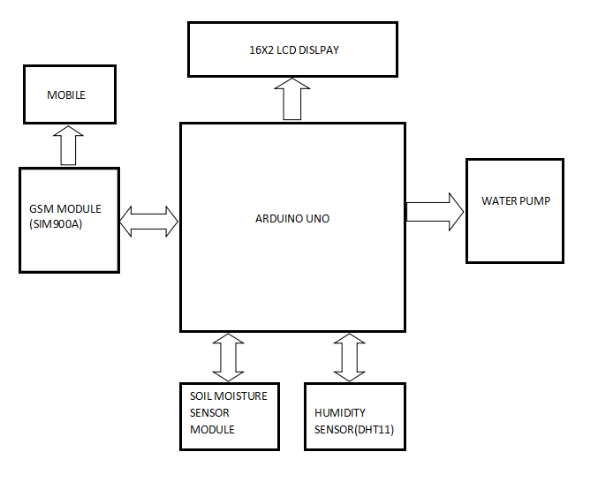



STEPPER MOTOR

SOIL MOISTURE SENSOR



MICROCONTROLLER

(C8051F340)

* 1. ***Description: -***

**CIRCUIT DIAGRAM-**

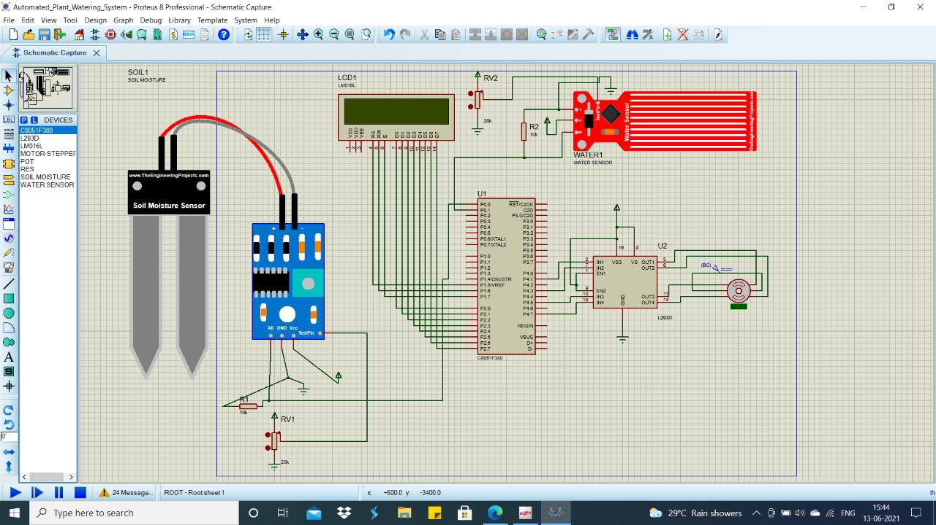

**CIRCUIT DIAGRAM EXPLANATION(WORKING)-**

In this circuit we have connected a soil moisture sensor to port 0.0 of Microcontroller C8051F340. Also, to the moisture sensor we have connected a resistance of 10k ohms and a variable resistor whose value we can change manually. Also, we have connected an LCD display to the microcontroller which will display our various conditions. To port 0.1 we have connected a water tank which will supply water to plant with the help of stepper motor. Water tank is also connected to a variable resistor whose value we can change manually and with the help of this resistor it will show the water level in the tank. The stepper motor attached controls the opening and closing of the valve of the tank to provide water supply.

In the soil moisture sensor, if the value of variable resistor is high the LCD will display "Low Moisture" and vice versa.

So, if the moisture sensor is low and there is adequate water in the water tank then with the help of stepper motor water will be supplied to the plant. After sometimes when there will be enough water provided the LCD will display "High Moisture".

If there is low moisture and the water level in the tank is also low then the LCD will display " Low tankwater".

* 1. ***Selection of Components and its specification: -***

**COMPONENTS-**

1. Soil Moisture sensor

This is an Electrical resistance Sensor. The sensor is made up of two electrodes. This soil moisture sensor reads the moisture content around it. A current is passed across the electrodes through the soil and the resistance to the current in the soil determines the soil moisture. If the soil has more water resistance will be low and thus more current will pass through. On the other hand, when the soil moisture is low the sensor module outputs a high level of resistance. This sensor has both digital and analogue outputs. Digital output is simple to use but is not as accurate as the analogue output.

1. Water level sensor

The water pump uses centrifugal force to send fluid to the outside while it spins, causing fluid to be drawn from the centre continuously. The inlet to the pump is located near the centre so that fluid returning from the [radiator](http://auto.howstuffworks.com/how-does-radiator-cap-work.htm) hits the pump vanes. The pump vanes fling the fluid to the outside of the pump, where it can enter the engine. The fluid leaving the pump flows first through the engine block and cylinder head, then into the radiator and finally back to the pump.

1. Microcontroller: C8051F340

The C8051F340-GQ microcontroller (MCU) features an on-board universal serial bus (USB) 2.0 function controller with an integrated transceiver and on-chip clock recovery. No external resistors, crystal, voltage regulator, EEPROM, or other components are required for USB applications. The MCU includes a powerful 8051 core with 50 MHz performance along with 64 kB Flash, 4.25 kB RAM. On-chip analog features include a 10-bit, 20-ch., 200 ksps ADC, voltage reference, a ±1.5 internal oscillator, 2 comparators, and a temperature sensor. Integrating additional communication interfaces along with rich analog in a 7x7 mm, QFP48, the C8051F340-GQ provides a truly single-chip solution for embedded USB applications.

1. Stepper motor

Stepper motors are DC motors that move in discrete steps. They have multiple coils that are organized in groups called "phases". By energizing each phase in sequence, the motor will rotate, one step at a time.

With a computer controlled stepping you can achieve very precise positioning and/or speed control. For this reason, stepper motors are the motor of choice for many precision motion control applications.

Stepper motors come in many different sizes and styles and electrical characteristics.

1. Variable resistors

A variable resistor is a resistor of which the electric resistance value can be adjusted.

We have used a variable resistor to vary the soil moisture and the tank water level.

1. Resistors

A resistor is a component that resists the flow of current. It’s one of the most basic components used in electronic circuits.

7) LCD Display

LCD (Liquid Crystal Display) screen is an electronic display module. A 16x2 LCD display is very basic module and is very commonly used in various devices and circuits. These modules are preferred over seven segments and other multi segment LED’s. The reasons being: LCDs are economical; easily programmable; have no limitation of displaying special & even custom characters (unlike in seven segments), animation and so on.

A 16x2 LCD means it can display 16 characters per line and there are 2 such lines. In this LCD each character is displayed in 5x7 pixel matrix. This LCD has two registers, namely, Command and Data.

The command register stores the command instructions given to the LCD. A command is an instruction given to LCD to do a predefined task like initializing it, clearing its screen, setting the cursor position, controlling display etc.

The data register stores the data to be displayed on the LCD. The data is the ASCII value of the character to be displayed on the LCD.

8) Driver L293D

L293D IC is a typical Motor Driver IC which allows the DC motor to drive on any direction. This IC consists of 16-pins which are used to control a set of two DC motors instantaneously in any direction. It means, by using a L293D IC we can control two DC motors. As well, this IC can drive small and quiet big motors.

This L293D IC works on the basic principle of H-bridge, this motor control circuit allows the voltage to be flowing in any direction. As we know that the voltage must be change the direction of being able to rotate the DC motor in both the directions. Hence, H-bridge circuit using L293D ICs are perfect for driving a motor. Single L293D IC consists of two H-bridge circuits inside which can rotate two DC motors separately. Generally, these circuits are used in robotics due to its size for controlling DC motors.

***2.4 Interfacing Diagram***

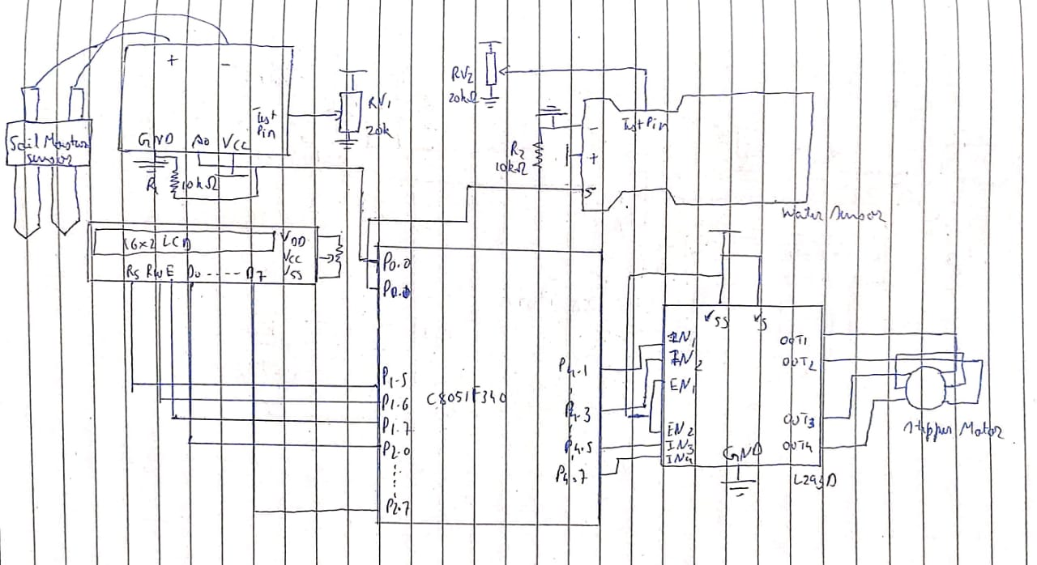

**Advantages:**

* It can be easily scaled, thus easy implementation on large lands
* Do data prediction and make it more feasible and automated system
* Low in cost because of low end components used.
* Used for sensing the moisture level of the soil in the field and recovering it by letting out sufficient water through the motor pump.
* LCD provides ease in the work as it helps the user know what the condition of the motor.
* The project gives a broad outlook to how modern farms and agriculture can help farmers know the status even by staying home.
* Highly sensitive
* Works according to the soil condition
* Fit and Forget system
* Low cost and reliable circuit
* Complete elimination of manpower
* System can be switched into manual mode whenever required
* Can be used for a small pot watering system at your house.

**Limitations:**

* System has a problem with the soil moisture sensor it can easily corrode. Rusting of the probe is a real problem. The carbon rod inside the batteries can be used. They are very good conductors and do not rust.
* Manual supervision is needed in case of an override.
* Basic setup for the fields will most likely be very complex.

**Future Scope:**

* Multiple plants can be watered by increasing the number of sensors in the system.
* GSM can be used so that the user can be notified whether his plants are required to be watered or not.
* IoT can be used to inform the user about the status of the motor.

**Future Enhancements**:

* A wireless sensor and GPRS (General Packet Radio Service) based automated plant watering system can also be employed, which will help monitor the soil moisture and to control the application of water to the agricultural products thereby saving water.
* Integration of faster processors and GSM 900A can be used to drive the motor remotely from hand via text messages and also create internet hotspot for further IoT applications
* Integration of Node MCU8266 to develop a remote server of storing and keeping track of data
* Do data prediction and make it more feasible and automated system.

1. **Software Design:**

**ALGORITHM:**

Step1: Soil moisture sensor is embedded in the soil

Step2: Water Sensor is embedded in the water tank

Step3: The setup is turned on

Step4: The soil moisture sensor gives input to the microcontroller regarding the moisture level

Step5: The microcontroller displays the status of the soil on the LCD display

Step6: According to the status of the soil moisture, the tank supplies water to the soil

Step7: The flow of the water is controlled by a valve which is opened and closed accordingly by a motor

Step8: If the water level is low, it is displayed on the LCD

Step9: The water tank is refilled

Step10: Repeat Steps 1 to 9 as necessary

**EMBEDDED C CODE:**

#include"c8051F340.h" /* Header file */

void DelayMs(unsigned int Ms); /* Forward declarations of functions used */

void Write_Command_Lcd(unsigned char Command);

void Write_Data_Lcd(unsigned char Character);

sbit LCD_RS=P1^5; /* Labels for the control signals */

sbit LCD_RW=P1^6;

sbit LCD_EN=P1^7;

sbit soil=P0^0;

sbit Tank=P0^1;

void main()

{

XBR1=0x40; /* Enable Crossbar for Port 1 and 3*/

P0MDIN=0x00; /* P0 pins configured as Digital Inputs*/

P2MDOUT=0xFF; /* Configuring Port 1 and Port 2 as output for the required lines */

P1MDOUT=0xE0;

P4MDOUT = 0xFF; /* All P4 pins configured as Output */

while(1)

{ /*Commands for LCDs */

Write_Command_Lcd(0x38); /* 0x38 command is sent to the 8-bit LCD which indicates 2 lines 5x7 matrix display */

DelayMs(200);

Write_Command_Lcd(0x01); /* 0x01 command to clear display */

DelayMs(200);

Write_Command_Lcd(0x0E); /* 0x0E to turn on display and cursor */

DelayMs(200);

Write_Command_Lcd(0x85); /* Address from which message is to be displayed */

DelayMs(200);

if(soil==1&&Tank==1) /* If the soil moisture low, and tank water level is high */

{

P4 = 0x80; /* Motor spins clockwise in full stepping mode */

DelayMs(1); /* Delay for controlling speed */

P4 = 0x20;

DelayMs(1);

{ /* For LCD display */

Write_Data_Lcd('L');

Write_Data_Lcd('O');

Write_Data_Lcd('W');

Write_Command_Lcd(0xc5); /* Message displayed from 5th position of the second line */

Write_Data_Lcd('M');

Write_Data_Lcd('O');

Write_Data_Lcd('I');

Write_Data_Lcd('S');

Write_Data_Lcd('T');

Write_Data_Lcd('U');

Write_Data_Lcd('R');

Write_Data_Lcd('E');

}

}

else if(soil==1&&Tank==0) /* If soil moisture level is low and tank water level is low */

{

{

P4 = 0x80; /* Motor spins anti-clockwise in full stepping mode */

DelayMs(1); /* Delay for controlling speed */

P4 = 0x08;

DelayMs(1);

}

Write_Data_Lcd('L');

Write_Data_Lcd('O');

Write_Data_Lcd('W');

Write_Command_Lcd(0xc5); /* Message displayed from 5th position

of the second line */

Write_Data_Lcd('T');

Write_Data_Lcd('A');

Write_Data_Lcd('N');

Write_Data_Lcd('K');

Write_Data_Lcd('W');

Write_Data_Lcd('A');

Write_Data_Lcd('T');

Write_Data_Lcd('E');

Write_Data_Lcd('R');

}

else

{

{ /* If soil moisture level is high */

P4 = 0x80;

DelayMs(1); /* Delay for controlling speed */

P4 = 0x08;

DelayMs(1);

} /*LCD display */

Write_Data_Lcd('H');

Write_Data_Lcd('I');

Write_Data_Lcd('G');

Write_Data_Lcd('H');

Write_Command_Lcd(0xc5); /* Message displayed from 5th position of

the second line */

Write_Data_Lcd('M');

Write_Data_Lcd('O');

Write_Data_Lcd('I');

Write_Data_Lcd('S');

Write_Data_Lcd('T');

Write_Data_Lcd('U');

Write_Data_Lcd('R');

Write_Data_Lcd('E');

}

}

}

void DelayMs(unsigned int Ms)

{

unsigned int n; /* Value of Ms = 1 n is for comparing */

unsigned int i; /* i is to generate delay of 1ms */

for(n=0;n<Ms;n++)

for(i=0;i<65;i++); /* Count 65 to generate 1ms delay */

}

void Write_Command_Lcd(unsigned char Command)

{ /* Data on Port2 needs to be understood as a command by the LCD */

LCD_RS=0; /* We write 0 to RS bit */

LCD_RW=0; /* We write 0 to RW bit */

P2=Command; /* Sending value to be sent on LCD to Port2 */

LCD_EN=1; /* Sending a high to low pulse on enable signal */

DelayMs(50);

LCD_EN=0;

}

void Write_Data_Lcd(unsigned char Character)

{ /* Data on Port2 needs to be understood as a command by the LCD */

LCD_RS=1; /* We write 1 to RS bit */

LCD_RW=0; /* We write 0 to RW bit */

P2=Character; /* Sending character to be displayed to Port2 */

LCD_EN=1; /* Sending character to be displayed to Port2 */

DelayMs(50);

LCD_EN=0;

}

**CODE SCREENSHOTS:**

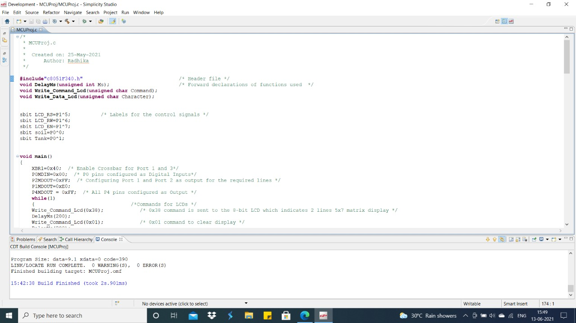

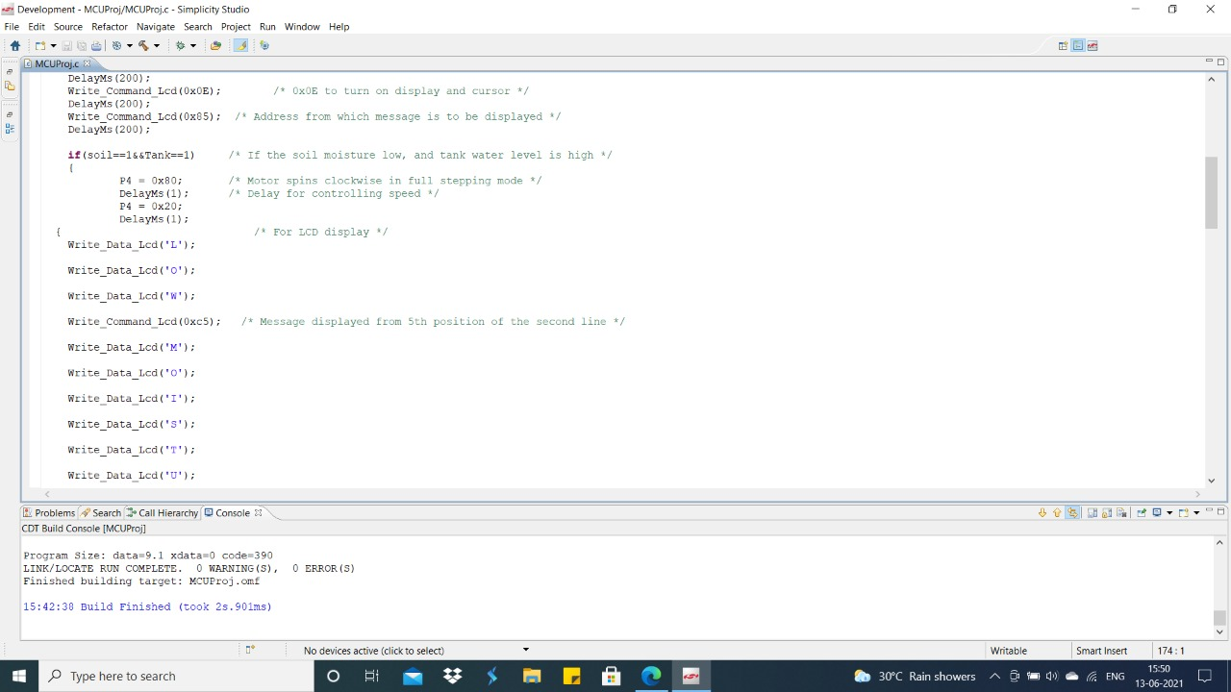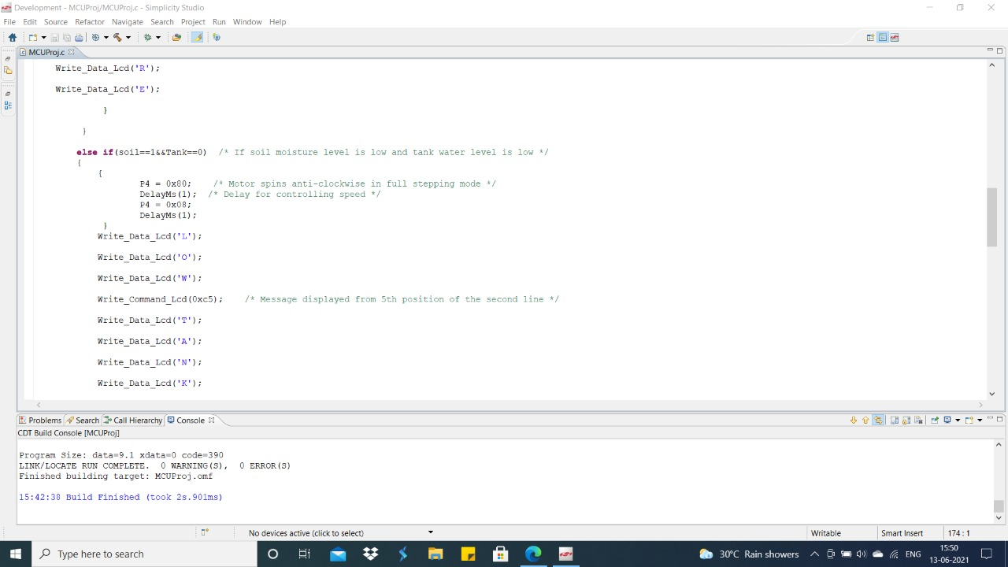

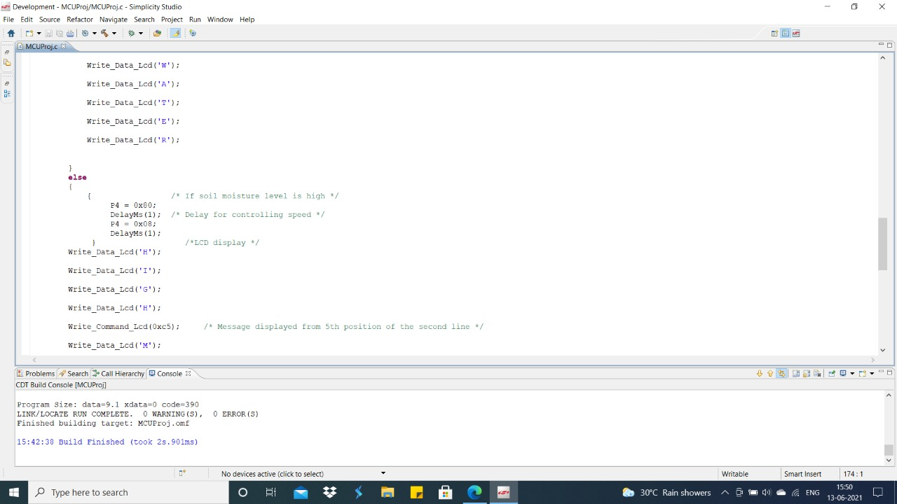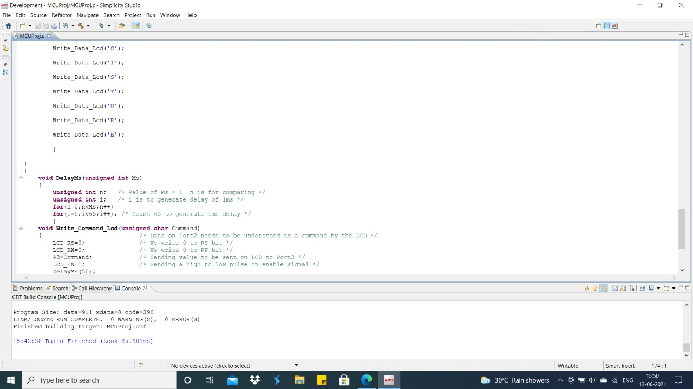

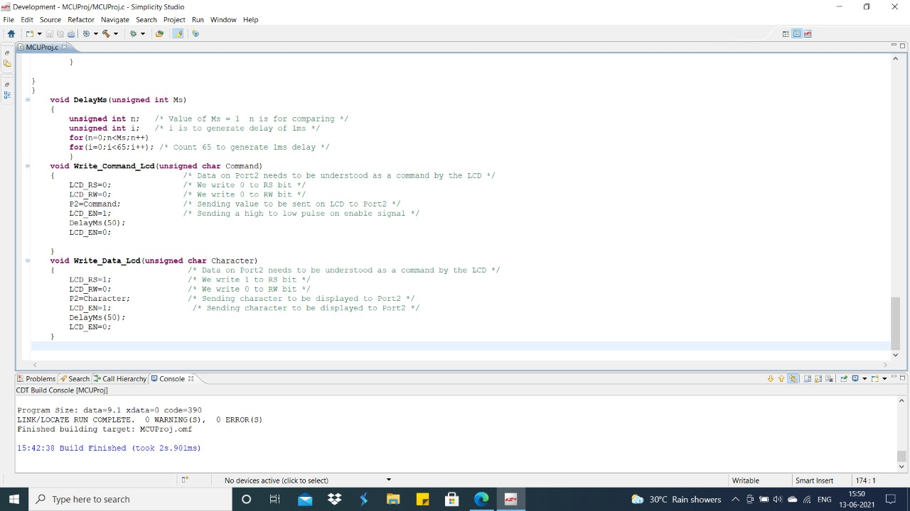

**OUTPUT:**



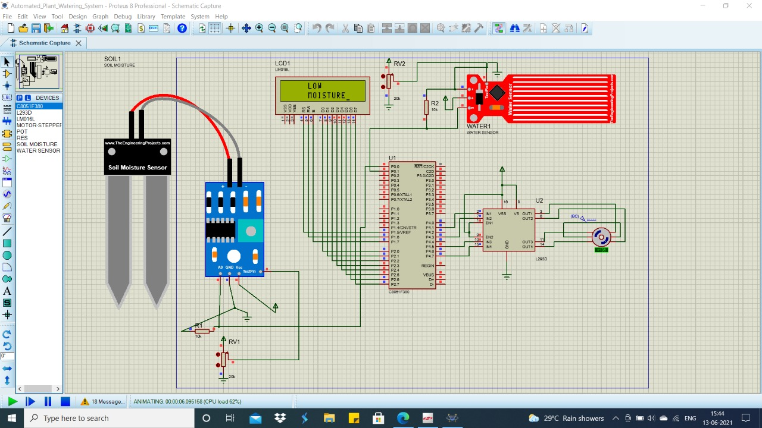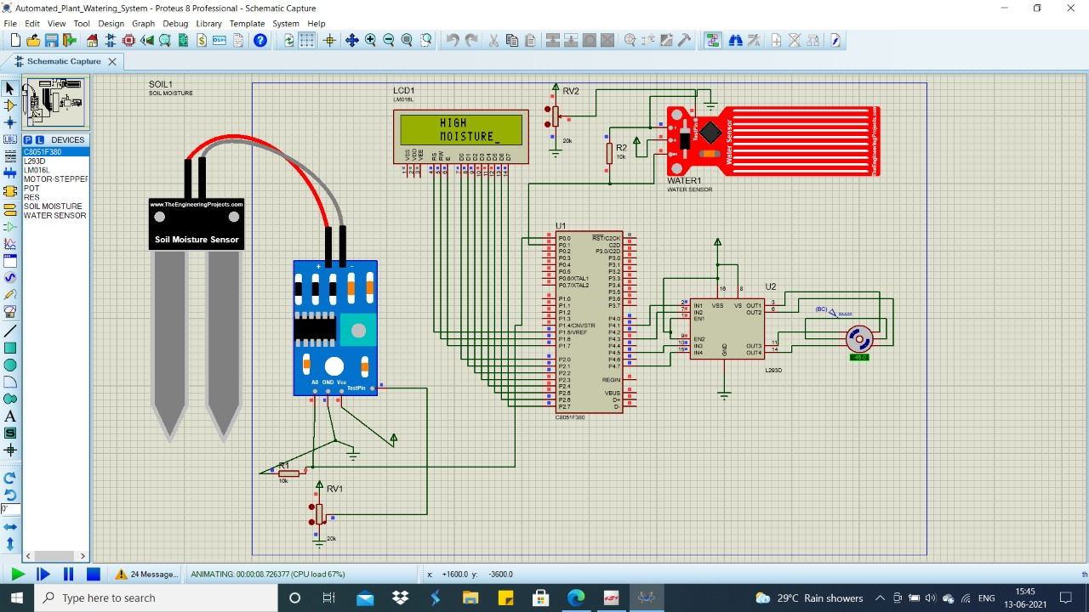

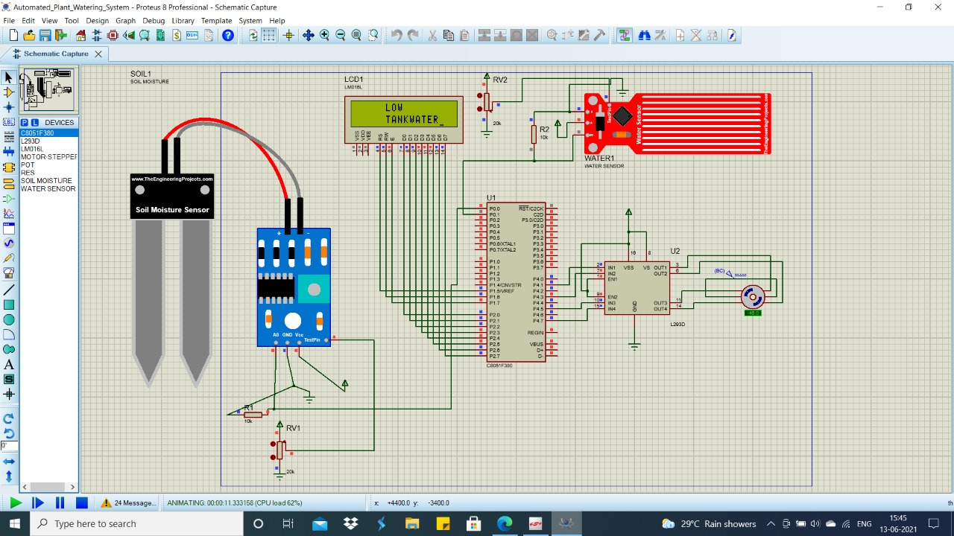

1. **Conclusion:**

Automatic plant watering control system has been designed and constructed. The prototype of the system worked according to specification and quite satisfactorily. The system components are readily available, relatively affordable and they operate quite reliably. The system helps to eliminate the stress of manual irrigation and irrigation control while at the same time conserving the available water supply. Improving Irrigation efficiency can contribute greatly to reducing production costs of agricultural products, thereby making the industry to be more competitive and sustainable. The system was tested on three types of soil and from the result analysis sandy soils require less water than loamy soils and clay soils require the most water for irrigation. For future work on this project, we recommend that for a large-scale implementation a more powerful water pump can be used. Also, the microcontroller is used to accommodate more than one sensor input and also control different irrigation regimes independently. A wireless sensor and GPRS (General Packet Radio Service) based automated plant watering system can also be employed, which will help monitor the soil moisture and to control the application of water to the agricultural products thereby saving water.

The circuit is more effective indoors if one intends to use it for long periods. This is because the water from reservoir (bucket, etc) evaporates rapidly if it is kept in the open. For regulating the flow of water, either a tap can be used or one end of a rubber pipe can be blocked using M-seal compound, with holes punctured along its length to water several plants.

**References:**

* [www.electronicsdigest.com](http://WWW.ELECTRONICSdigest.com)
* [www.electronicsgarage.com](http://www.electronicsgarage.com)
* [www.electronicsforu.com](http://www.electronicsforu.com)
* [www.electronicshub.com](http://www.electronicshub.com)